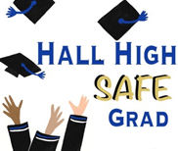
Submit Photos for Baby Board

February 23, 2019

Dear Fellow Senior Parents,

It’s hard to believe the Safe Grad Party is 4 months away! The committees are working hard getting things organized and preparing for this wonderful event for our seniors!

The Baby Board Committee is requesting 2 photos of your child. These photos will be displayed on a wall for the students to peruse and guess which baby picture goes with the graduating senior!

This is what we need:

- One picture under the age of 3 (no nudes, please)
- One current picture.

Photos should be no larger than 4 x 6

Kindly email them in jpeg format to Lisa Mahoney (lrmwing@gmail.com) with student name as the subject.

We appreciate your time in getting these to us by March 30th, 2019.

Feel free to contact Melissa Morin (mapmorin@comcast.net) with questions or concerns.

Thank you,

The Baby Board Committee

